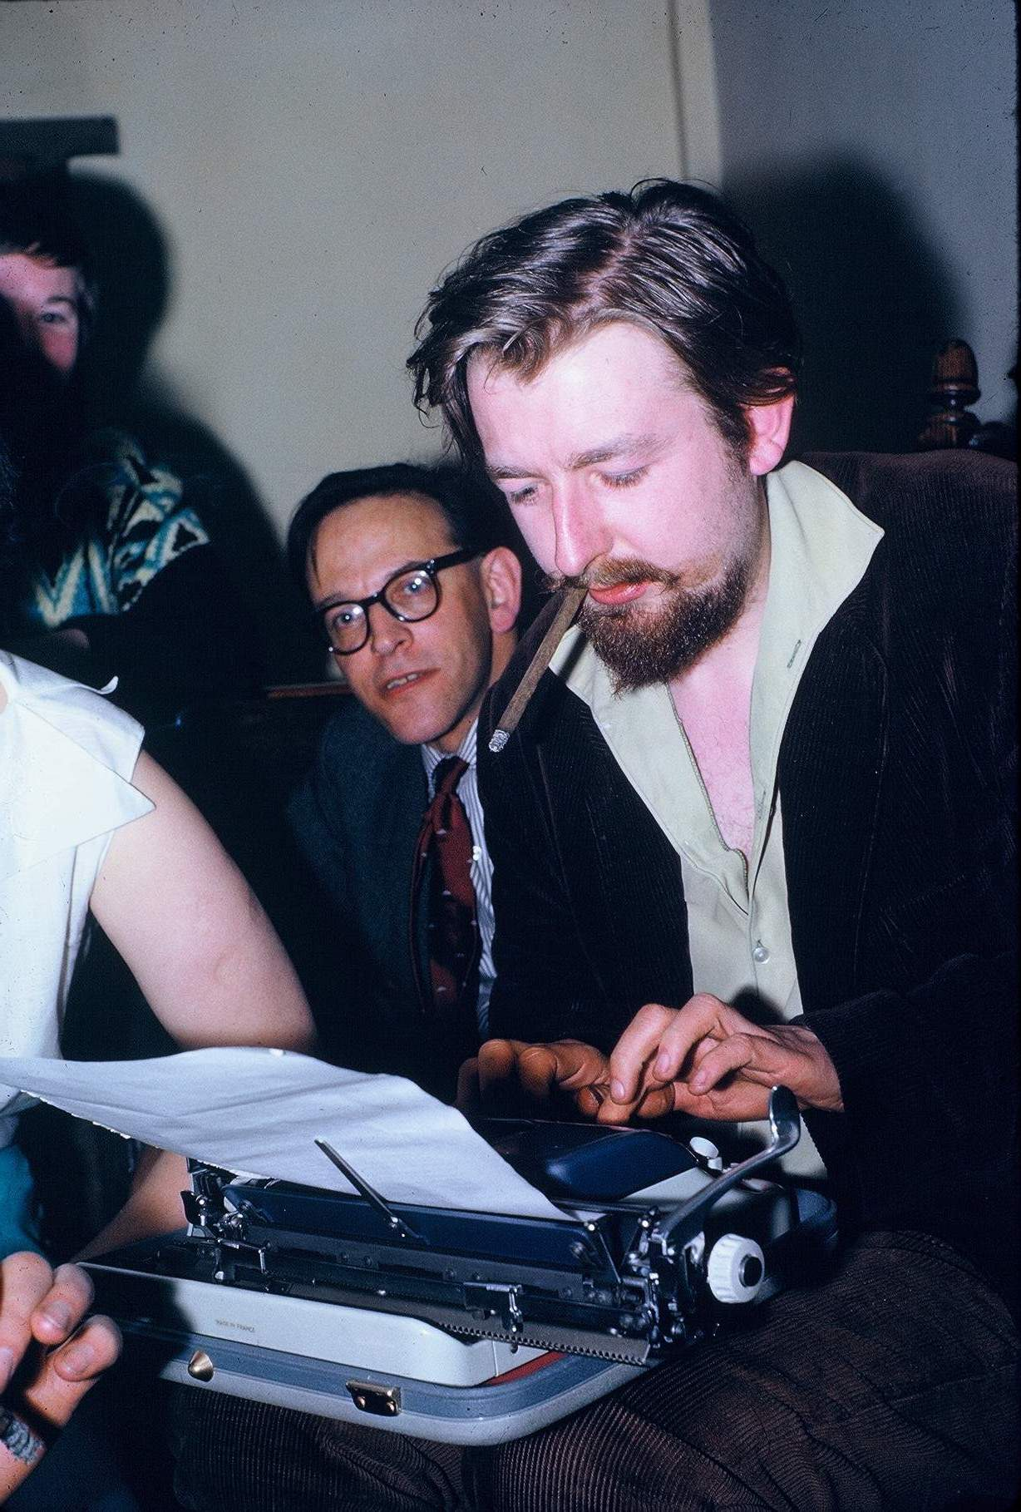
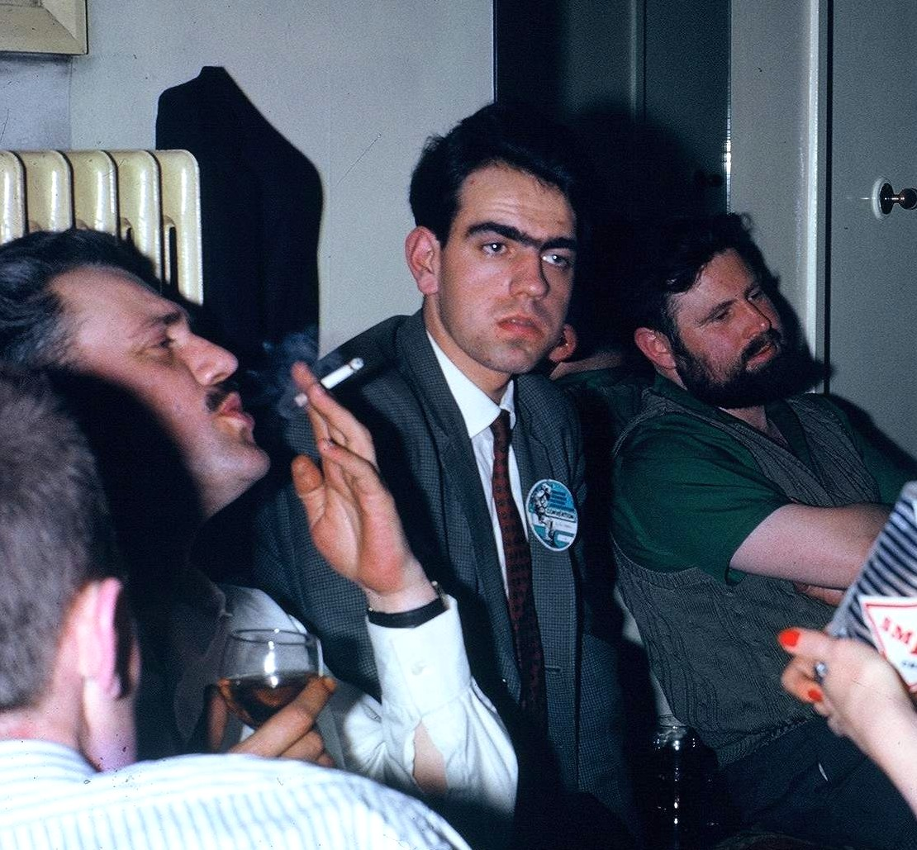
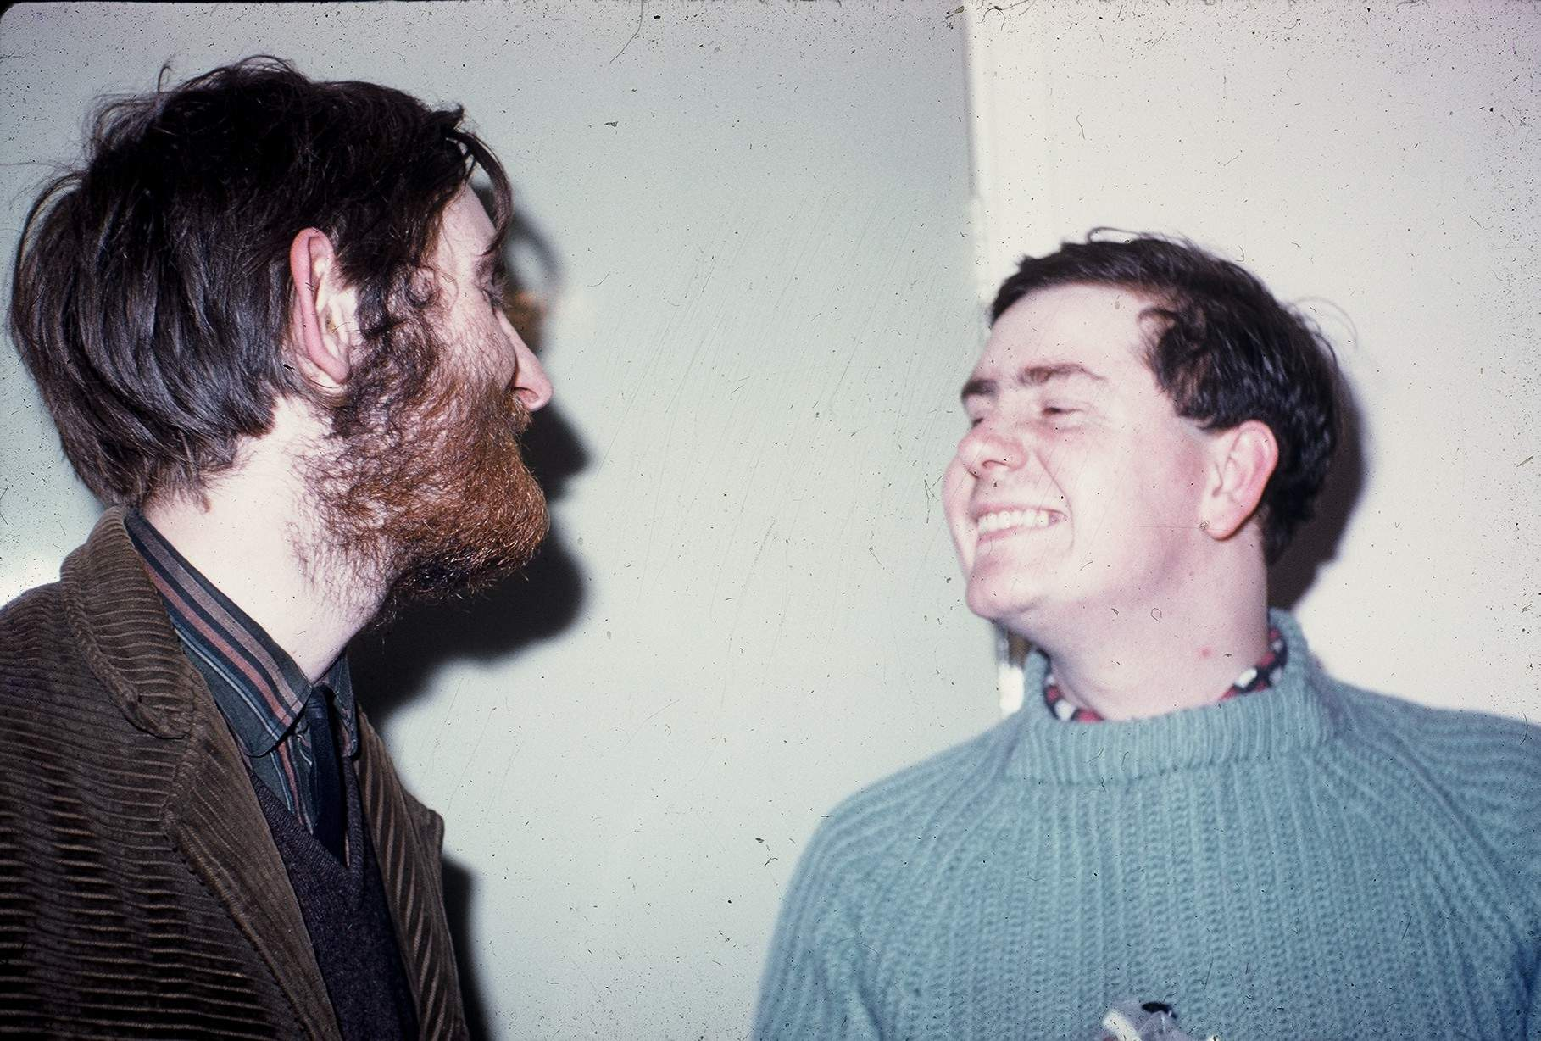
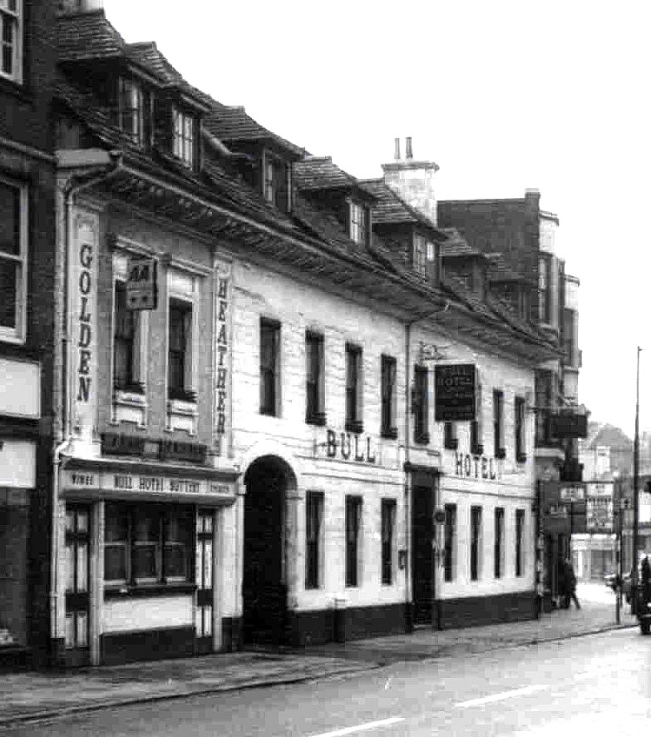
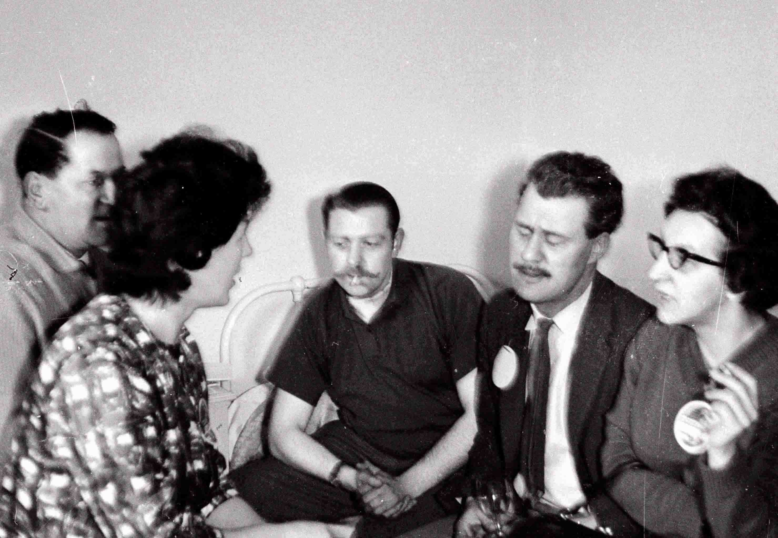
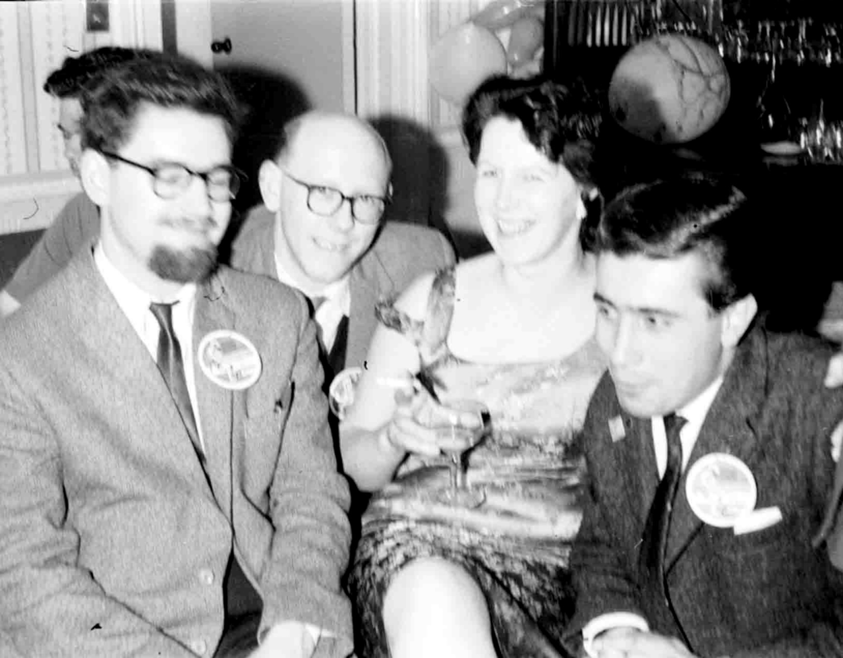
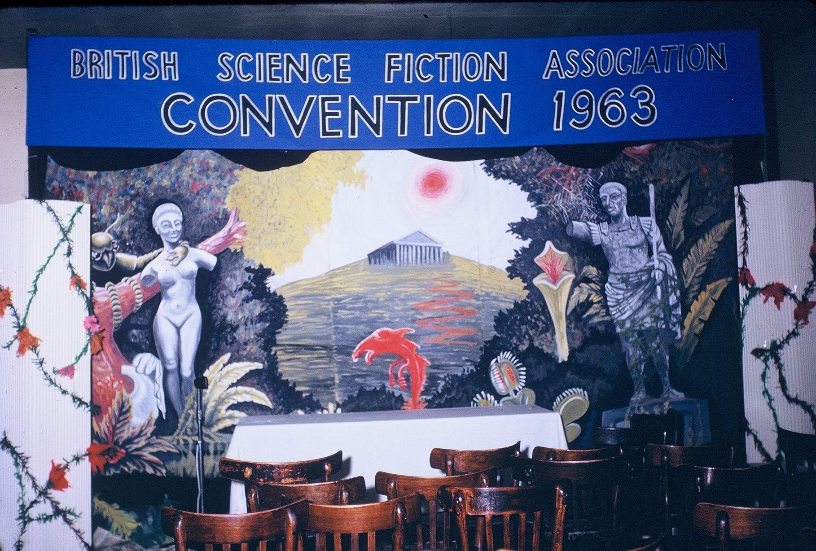
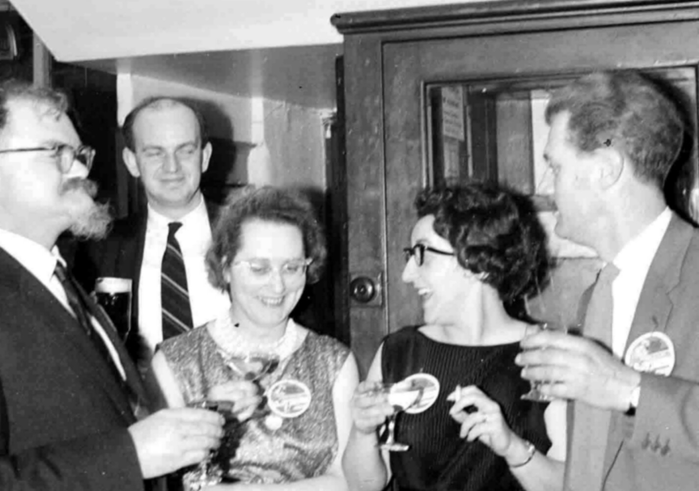

(Left): Neo-fan Lang Jones appears shell-shocked by the exalted company of Phil & Archie!
(Top left): Back in 1963 Ken had an evil beard!

(Top right):
Backdrop at Bullcon

(Right): Who is the mystery man? – he is not Robert Silverberg!

(Above): ‘Michael Moorcock came to the Peterborough convention like a young God’

(Below): The Bull, before it was face-lifted!

(Right): Alan is
glad to see Ken
in cheerful mood.

(Right):
In those days
Eddie had
handlebars!

