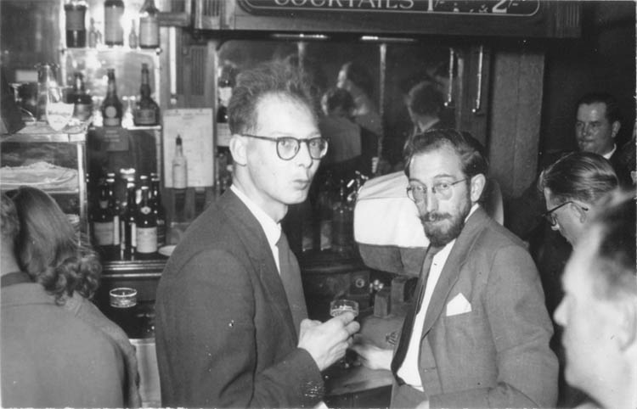
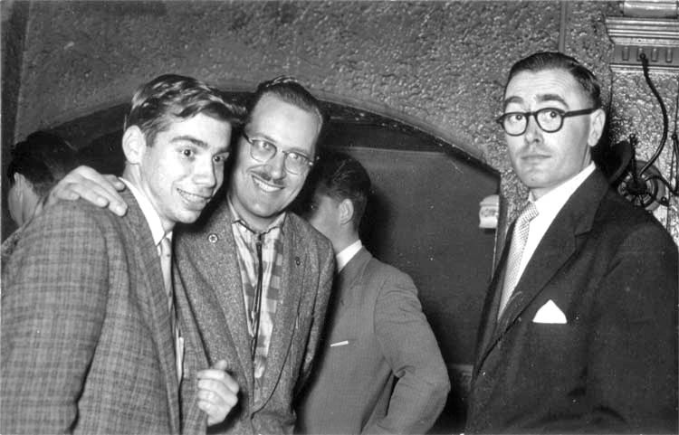
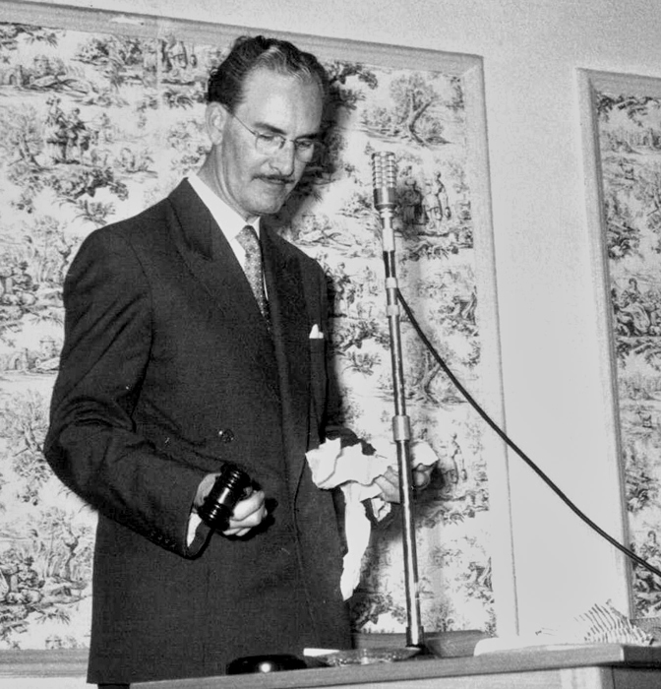
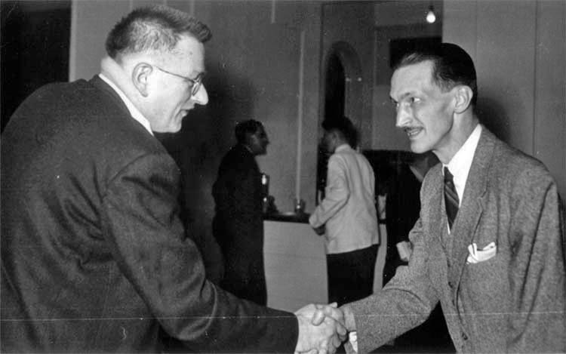
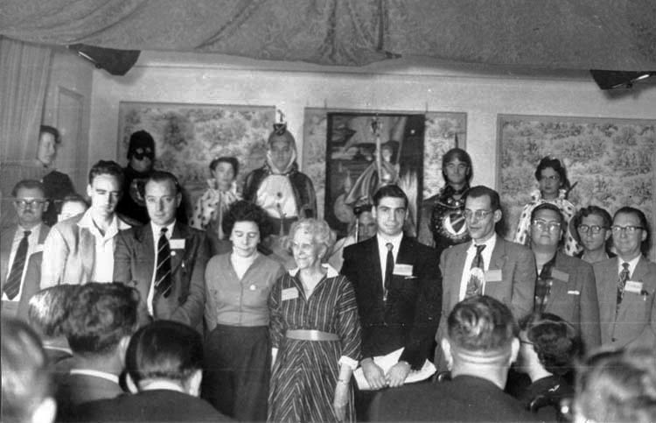
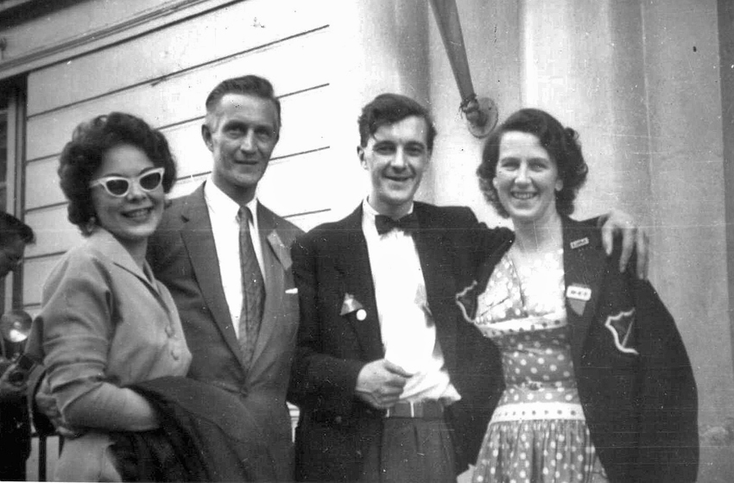
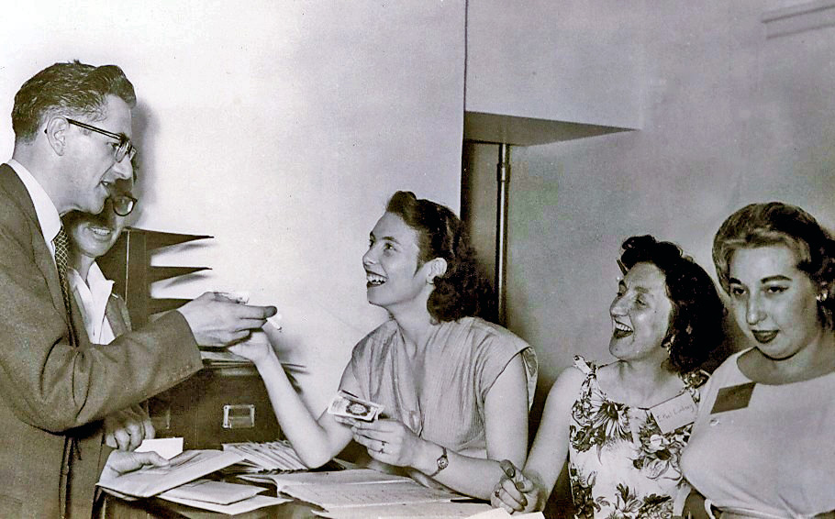
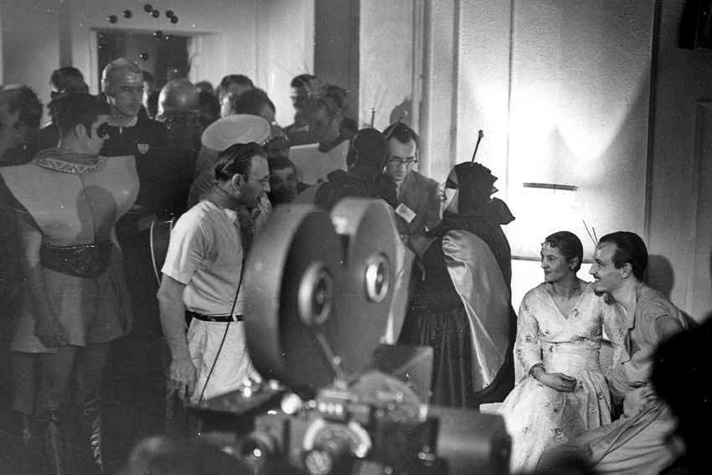
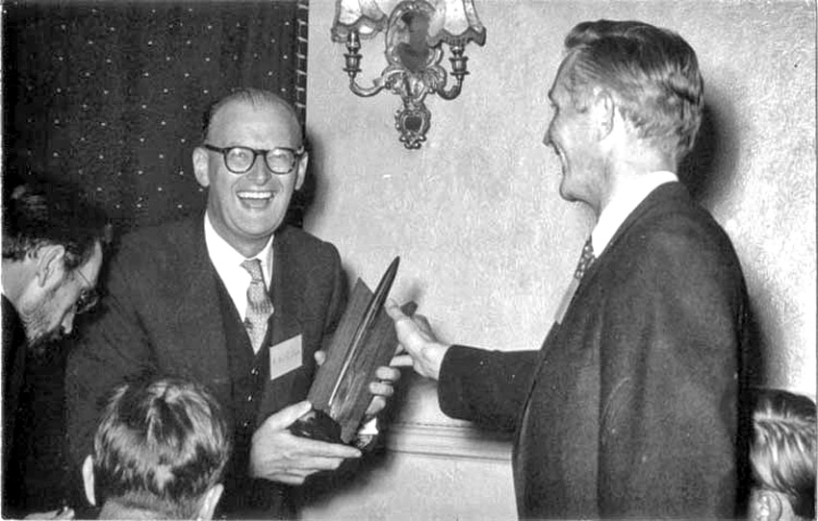
Snog and drink
Blog in the Fog!
Loncon 1957 - The first British worldcon

Chairman John Carnell conducts the auction.

Above; John Newman in the bar with Ken Bulmer (right) one of the main promoters of Loncon

Left: Bob Silverberg, Forry Ackerman, James White.
Left: John W. Campbell (GoH) greets H. Beam Piper.

Right: Newly-weds Ruth & Dave Kyle with Norman & Ina Shorrock
Above, top; Ted Tubb with Pam Bulmer & Ethel Lindsay

Above; Arthur C. Clarke receives 1956 Hugo Award from Dave Kyle for CHILDHOOD’S END
Top; End of St. Fantony ceremony. In front row are Ken Slater, Willis, Jeeves, who else can you recognise?

Below: John & Marjorie Brunner in costumes are filmed by the BBC and Alan Whicker at the Fancy Dress Party

